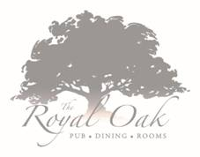
Summer Set Menu
Starters
Warm homemade bread and dips and mixed marinated olives
Homemade beef meatballs, rich chorizo and tomato sauce and toasted ciabatta
Halloumi fries with a spring onion, coriander and chilli salad and a yoghurt, harissa and saffron dip
Smoked mackerel pate, beetroot and celeriac slaw, horseradish dressing and toasted ciabatta

Mains
Char grilled chicken breast skewer flavoured with lemon, garlic and oregano. Served with Greek salad including feta cheese, olives, tomato and red onion, hummus, flatbread and fries
Fish and chips – Fresh fish cooked in our own beer batter with hand cut chips, minted pea puree and homemade tartare sauce
Grilled feta cheese served with citrus and herb giant cous cous, hummus, char grilled flatbread and Greek salad (v)
Homemade 8oz beef burger, bacon jam, crispy onions, chaddar cheese with gem lettuce and beef tomato. Served in a brioche bun with salad and skinny fries
Ham, egg and chips – slow cooked ham hock with a honey mustard glaze, chunky chips, fried egg and pineapple ketchup

Desserts
Raspberry & white chocolate Eton Mess
Sticky toffee pudding with crème Anglasie
3 scoop selection of ice cream or sorbets
2 Course £13.50 3 Course £17.00

