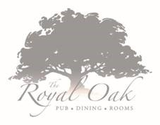

English Pub Classics
Taster Menu
Monday 29th July
Starter Bites
Prawn cocktail
Garlic mushrooms on brioche
Chicken liver parfait on toast
Round 1
Beer battered monkfish, triple cooked chips, homemade ketchup, pea beignet
Beef burger slider, cheddar cheese, onion jam and onion rings
Round 2
Chicken and ham pie, vegetables
Wild boar sausage, pomme puree, onion gravy

Desserts
Raspberry & white chocolate Eton mess
Or
Treacle sponge and custard

We must be informed of all dietary requirements when booking

£25 per person

