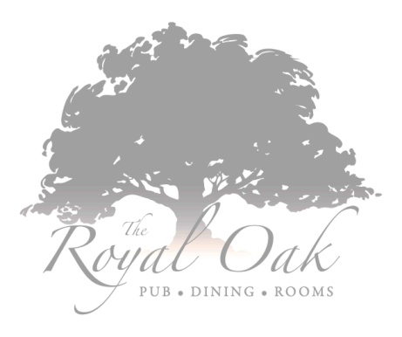

**Served from 12.00pm – 2.30pm & 5.30pm - 6.30pm**

*We respectfully require the table back after 1 hour 30 minutes*

**Starters**

Warm breads, dips and olives (v)

Homemade soup of the day served with warm bread (v)

Thai fishcakes, Asian slaw, lime and sweet chilli sauce

Ham hock terrine with dressed leaves, red onion jam and toasted ciabatta

**Mains**

Homemade pie of the day served with mashed potato, roasted root vegetables and gravy

Pan roasted chicken breastwith cauliflower puree, stir fried pancetta and vegetable pearl barley with chicken jus

Fish & Chips **–** Fresh fish cooked in our own beer batter with hand cut chips, minted pea puree and homemade tartare sauce

Ham, Egg & Chips – Slow cooked ham hock with honey-mustard glaze, chunky chips, fried hens’ egg, petit pois and pineapple ketchup

Pan fried Halloumi cheese, Mediterranean vegetable ratatouille and caramelised red onion served with red pepper pistou and fresh basil (v)

**Desserts**

3 scoops of ice creams or sorbets

Warm chocolate fudge brownie with chocolate sauce and vanilla ice cream

Raspberry and white chocolate Eton mess

**2 Course £13.50 3 Course £17.00**